The Afghan Special Immigrant Visa Program, 2009-2020

What is the Afghan Special Immigrant Visa Program?
- In 2009, Congress passed the Afghan Allies Protection Act of 2009. The Act provided special immigrant visas (SIVs) to Afghans who had worked for at least one year as translators or interpreters, or who were employed by, or on behalf of, the U.S. government in Afghanistan, and whose lives were threatened because of their work in support of the U.S. mission. The visas allow these wartime allies to resettle in the United States.
- A similar program was enacted in 2008 for Iraqi translators, interpreters, and workers, but that program stopped accepting new applications in September 2014, and now those Iraqi wartime allies apply directly to the U.S. Refugee Admissions Program through a Direct Access Program.

Why is the Afghan Special Immigrant Visa Program Important?
- U.S. military involvement in Afghanistan continues. We cannot complete our mission there without the Afghan translators, engineers, security guards, embassy clerks, logisticians, cultural advisors, and soldiers who stand by us. Many of these allies and their families now face death threats for their service to the U.S. We gave our word to protect these allies--a promise that we have kept since 2009.
- The Afghan Special Immigrant Visa program represents a promise that we made to our wartime allies. Following through on that promise is not only vital to maintaining support of the Afghan people, it is vital to completing our mission there and to for future wars in which we may be engaged.
- Likewise, as the U.S. continues to protect its interests elsewhere around the world, it will need the continued assistance of those willing to stand with us. We must ensure that the U.S. is known as a country that keeps its promises and never forgets its allies. Continuing to reauthorize the Afghan Special Immigrant Visa program and increasing the number of visas to accommodate the need of our allies sends the message that the U.S. never leaves anyone behind.
Legislative History of the Afghan Special Immigrant Visa Program
- From Fiscal Years (FY) 2009-2013, 1,500 Afghan SIV’s were allocated per year. In the 2014 Consolidated Appropriations Act, three thousand SIV’s were allocated for the year, with an additional one thousand allocated for 2014 through the Emergency Afghan Allies Extension Act.
- In FY 2015 and 2016, Congress authorized additional Afghan SIV’s though the National Defense Authorization Act (NDAA). For FY 2015, four thousand visas were allocated. For FY 2016, an additional three thousand SIV’s were authorized. The FY 2016 NDAA also increased the minimum work requirement to two years for Afghan SIV recipients.
- The NDAA for FY 2017 allocated 1,500 SIVs and reauthorized the Afghan SIV program for an additional four years. FY 2017 NDAA’s authorization of only 1,500 additional proved to be insufficient to service the need of our Afghan allies. In March 2017, the U.S. embassy in Kabul stopped interviewing Afghans applying for the Special Immigrant Visa program. Recognizing the visa shortage crisis, in May 2017, through the Consolidation Appropriations Act, an additional 2,500 visas were allocated to Afghan principal applicants.
- The Consolidated Appropriations Act for FY 2018 allocated an additional 3,500 Afghan SIVs.
- In February 2019, Congress approved a FY 2019 omnibus appropriations bill which included an additional four thousand visas for allies who served alongside the U.S. mission in Afghanistan, supporting the Afghan SIV program through the rest of the fiscal year.
- The Further Consolidated Appropriations Act for FY 2020 authorized 4,000 additional SIVs for Afghan principal applicants.

Current Status and Fiscal Year 2021 Requests for the Afghan Special Immigrant Visa Program
- As of March 31, 2020, the Department of State has issued 15,093 out of the 22,500 SIVs available at that time to Afghan applicants. However, 8,744 Afghan applicants are still waiting at some point in the application phase. There are currently 7,407 visas remaining.
- The House of Representatives FY 2021 State, Foreign Operations and Related Programs appropriations bill includes an additional allotment of 4,000 Afghan Special Immigrant Visas (SIVs) and extension of the program for another year. The Senate has yet to take up FY 2021 appropriations bills. There is also a bipartisan coalition of U.S. Senators who have urged the Senate Armed Services Committee in their negotiations with House counterparts to include authorization of an additional 4,000 Afghan SIVs and extension of the program in the final FY 2021 National Defense Authorization Act.

Addressing Slow Processing Times for Afghan Special Immigrant Visa Applicants

- Although a historically high number of Afghan SIVs were granted in 2017, arrivals have slowed in the last two years.
- Despite the expectation that every visa allocated by Congress in a fiscal year will be processed, less than 50% of allocated visas were actually issued to eligible Afghans between 2018-2020. Further delays in consular processing and international travel due to the COVID-19 pandemic are expected to cause the longest wait times since the program’s inception.
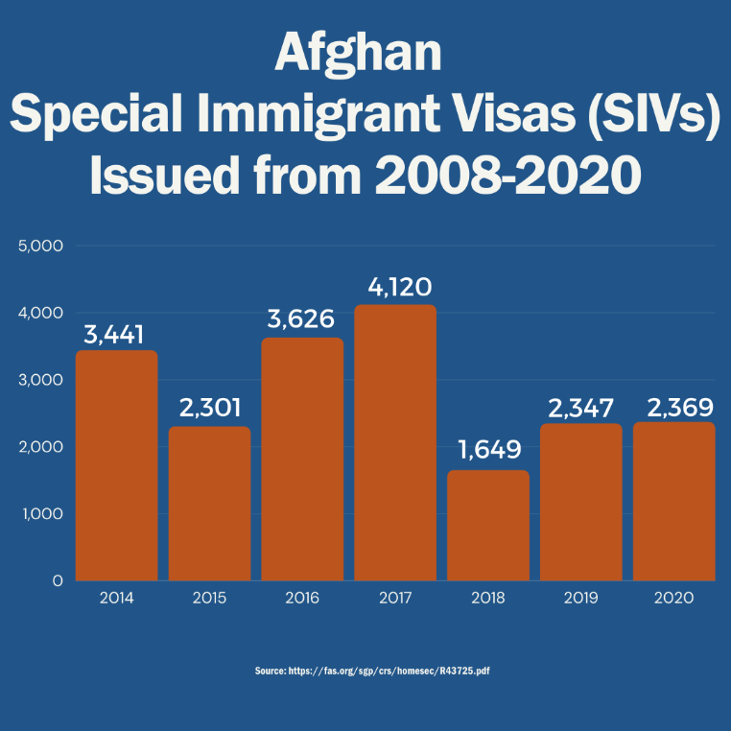
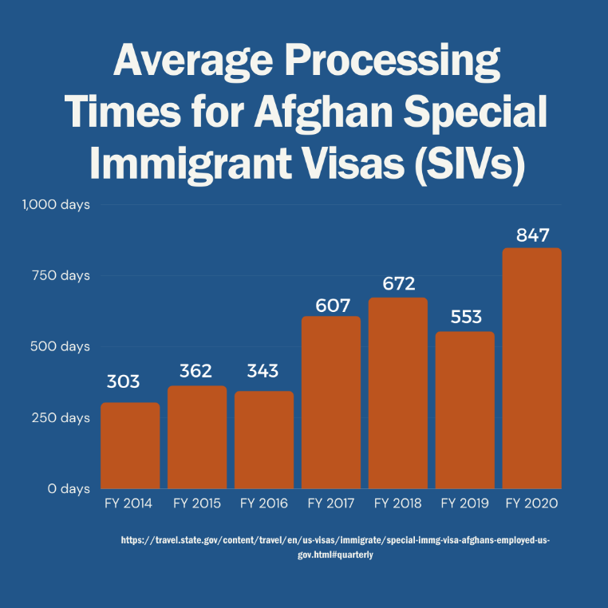

Litigation on Behalf of Afghan Special Immigrant Visa Applicants
- In September 2019, a federal judge ruled in Afghan and Iraqi Allies v. Pompeo that delays in excess of nine months in processing Afghan SIVs was unreasonable and unlawful. Despite the Congressional mandate that SIV applicants should receive a decision within nine months of submitting their application, the court noted that Afghan SIV applicants waited, on average, more than four years before receiving a visa.
In May 2020, the parties to this lawsuit submitted a joint plan to address delays in SIV processing. The joint plan requires the government to adjudicate 10,000 outstanding applications within set timeframes, including an initial grant or denial of employment eligibility within 120 days.

https://www.state.gov/j/prm/releases/factsheets/2016/254650.htm
https://fas.org/sgp/crs/homesec/R43725.pdf
https://travel.state.gov/content/dam/visas/SIVs/Afghan%20SIV%20public%20report_Jan%202016.pdf
https://travel.state.gov/content/dam/visas/SIVs/Afghan-Public-Quarterly-Report-Q2-April-2020.pdf
https://www.congress.gov/bill/116th-congress/house-bill/7608?q=%7B%22search%22%3A%5B%22h.r.+7608%22%5D%7D&s=1&r=1
https://www.shaheen.senate.gov/news/press/shaheen-calls-for-additional-visas-for-afghan-interpreters-and-support-staff-in-annual-defense-bill
https://refugeerights.org/press-release-court-finds-visa-delays-faced-by-thousands-of-afghans-and-iraqis-who-assisted-the-united-states-are-unlawful/
https://refugeerights.org/government-submits-plan-to-process-thousands-of-delayed-siv-applicants/

